Question 1:

Screenshot of Output:

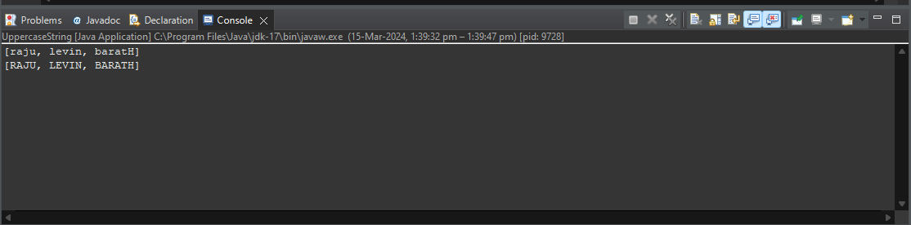

Question 2:

Screenshot of Output:

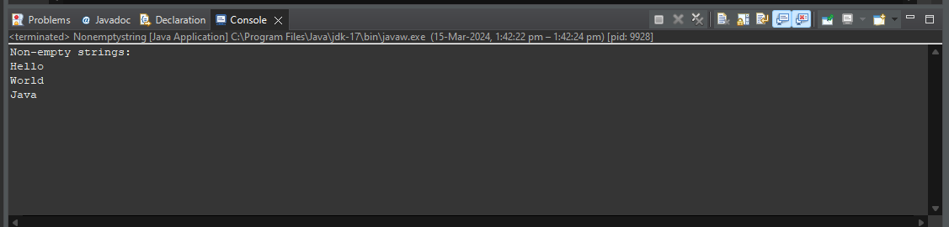

Question 3

Screenshot of Output:

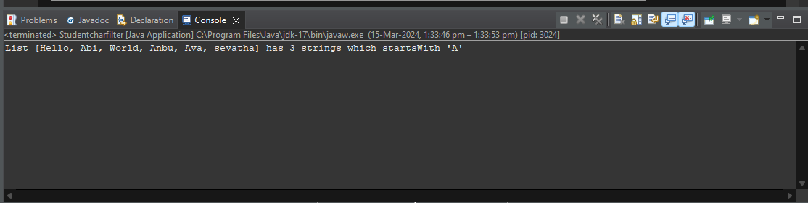

Question 4:

Screenshot of Output:

